### BIOLOGY TEST TWO

Name: _____________________________________________________________________

Mark: /54

**SECTION A: MULTIPLE CHOICE ( 8 marks)**

Please answer on the multiple choice answer grid below.

1. A B C D

2. A B C D

3. A B C D

4. A B C D

5. A B C D

**1.** Skin is:

(a) connective tissue

(b) epithelium tissue

(c) nerve tissue

(d) muscle tissue

**2.** The images on the right are all examples of:

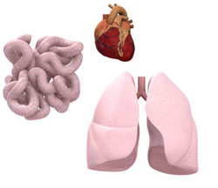

(a) tissues.

(b) organs.

(c) systems.

(d) cells.

**3.** The two types of digestion are:

1. chemical and muscular
2. chemical and mechanical
3. mechanical and hormone action
4. chewing and churning in the stomach

4. In humans Oxygen moves from the air to the blood in the organs called the:

1. heart
2. testes
3. lungs
4. stomach

5. In humans the pump for the circulatory system is the:

1. heart
2. testes
3. lungs
4. stomach

**SECTION B: SHORT ANSWER (46 marks)**

1. Connect the correct word to the correct definition using a line ( 10 marks)

|  |  |  |
| --- | --- | --- |
| Words | Draw Line | Definition |
| Digestion |  | A group of tissues working together to do a particular job. |
| Vas Deferens |  | The bones that make up the “backbone” |
| Tibia |  | The type of muscle that is attached to and moves bones. |
| Matrix |  | The breakdown of large food particles into molecules small enough to be absorbed by the body |
| Organ |  | A framework in which living cells are imbedded |
| Oviduct |  | Chemicals that help break food down |
| Digestive enzymes |  | A tube that carries eggs (ova) from the ovaries to the uterus. |
| Skeletal |  | The type of muscle found in the heart |
| Vertebrae |  | The shin bone. One of the bones between the knee and the ankle. |
| Cardiac |  | The tube that carries sperm from the testes to the urethra. |

**2.** Circle the term that best describes the organism in the picture on the right.

(1 mark)

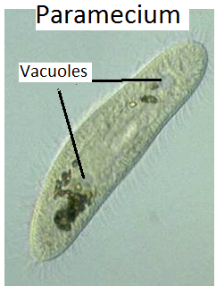

Multicellular Plant cell Unicellular

**3.** Label the diagram below that shows the levels of organisation. (5 marks)

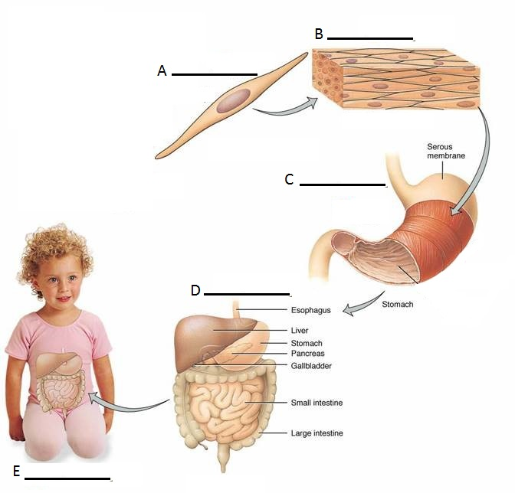

**4.** Circle either true or false for the following statements. (4 marks)

Many nerve cells grouped together are called nerve tissue. True False

A donkey is a multicellular organism. True False

The testes produce eggs. True False

Eggs in the female reproductive system are actually cells. True False

**5. Use the diagram below to complete the table that follows**

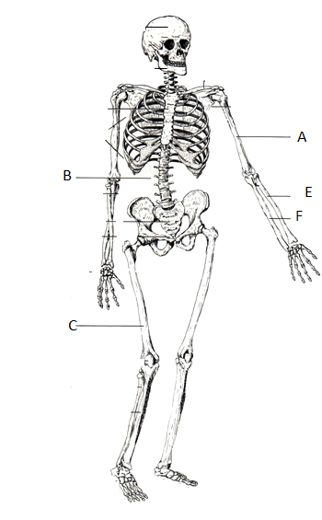

|  |  |
| --- | --- |
| LETTER | BONE NAME |
| A |  |
| B |  |
| C |  |
| D |  |
| E |  |
| F |  |

(6 MARKS)

**6. Use the diagram below to complete the table that follows**

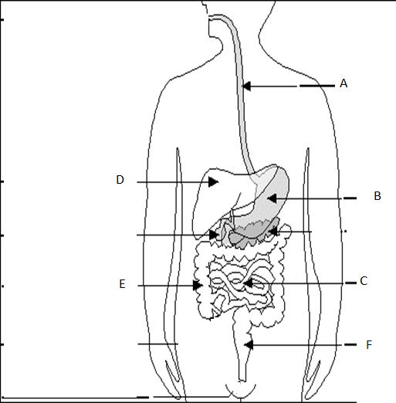

|  |  |
| --- | --- |
| LETTER | ORGAN NAME |
| A |  |
| B |  |
| C |  |
| D |  |
| E |  |
| F |  |

(6 MARKS)

7. **Use the diagram below to complete the table that follows**

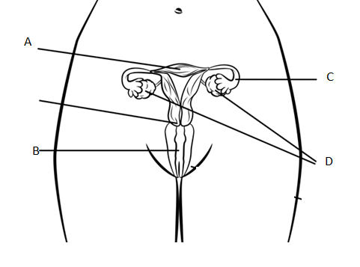



|  |  |
| --- | --- |
| LETTER | Name of structure |
| A |  |
| B |  |
| C |  |
| D |  |

(4 MARKS)

1. In which structure in the diagram above are the eggs (ova) made?

_______________________________________________________

1. In which structure in the diagram above does the foetus (baby) develop?

_______________________________________________________

(2 MARKS)

8. Your resting heart rate indicates how well your heart pumps blood through your body. Your pulse rate and how quickly it takes to recover to normal after exercise is a useful tool for finding your fitness level.

People who train regularly tend to have lower resting heart rates because their training helps their heart muscles to pump a more of blood with each heartbeat.

Resting Heart Rate Chart for Men (18-25 year old) and Level of fitness

|  |  |
| --- | --- |
| Level of fitness | Average Resting Heart Rate(Bpm) |
| Athlete | 50 |
| Excellent | 55 |
| Average | 70 |
| Poor | 85 |

1. Draw a suitable graph for the table above.

(5 marks)



1. John was sitting watching TV. His resting heart rate was 60bpm. He then went out and rode his bike. While riding his bike his heart rate went up to 100bpm. Why did this happen?

_________________________________________________________________________________________________________________________________________________________________________________________________________________________________________________________________________________________________________________________________________________________________________________________________________________________________________________________________________________________________________________

(3 marks)